**CHAPTER 11.Database**

1.CREATE database [DATABASE_NAME];

2.CREATE TABLE [TABLE_NAME]({CN1},{CN2},{CN3});

3.STRING NEED A Varchar(N)

4.SELECT [COLUMN_NAME]/* FROM [TABLE_NAME]

(WHERE+FILTERING CONDITION)

(ORDER BY C_N ASC/DESC);

5.INSERT INTO [TABLE_NAME] VALUES({CN1'},{CN2'},{CN3'});

6.UPDATE TABLE_NAME SET +REQUIREMENT/COMMAND+ (WHERE+FILTERING CONDITION);

7.DELETE FROM TABLE_NAME WHERE+FILTERING CONDITION;

8.ALTER TABLE_NAME ADD C_N/PRIMARY KEY/FOREIGN KEY (REFERENCES PRIMARY KEY2);

9. SELECT C_N/* FROM TABLE_NAME1 INNER JOIN TABLE_NAME2 ON [TABLE1.PRI_KEY=TABLE2.PRI_KEY] +WHERE + FILTERING CONDITION);

10.SELECT C_N/* FROM TABLE_NAME1,TABLE_NAME2,TABLE_NAME3... WHERE [TABLE1.PRI_KEY=TABLE2.PRI_KEY] ... AND FILTERING CONDITION;

11. SELECT C_N1, SUM/AVG/MAX/MIN/COUNT(C_D2) AS "NAME" FROM TABLE_NAME GROUP BY C_N1;

Flat-file database扁平文件

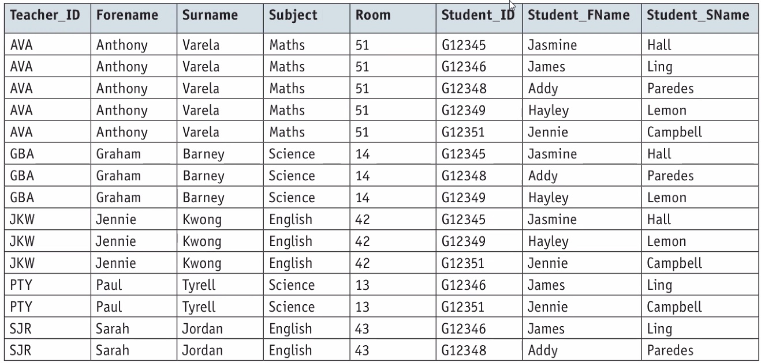

1NF:Each field is atomic, no repeated groups of attributes

2NF:No partial dependencies

3NF:No transtive dependencies

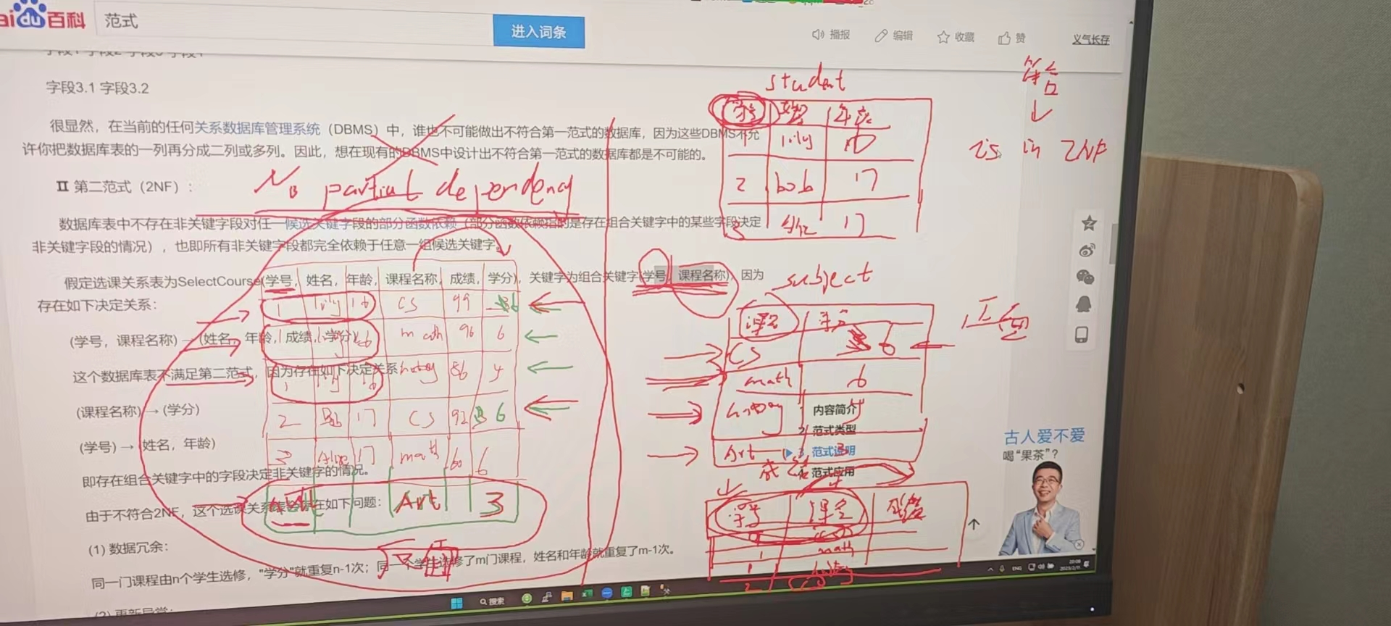

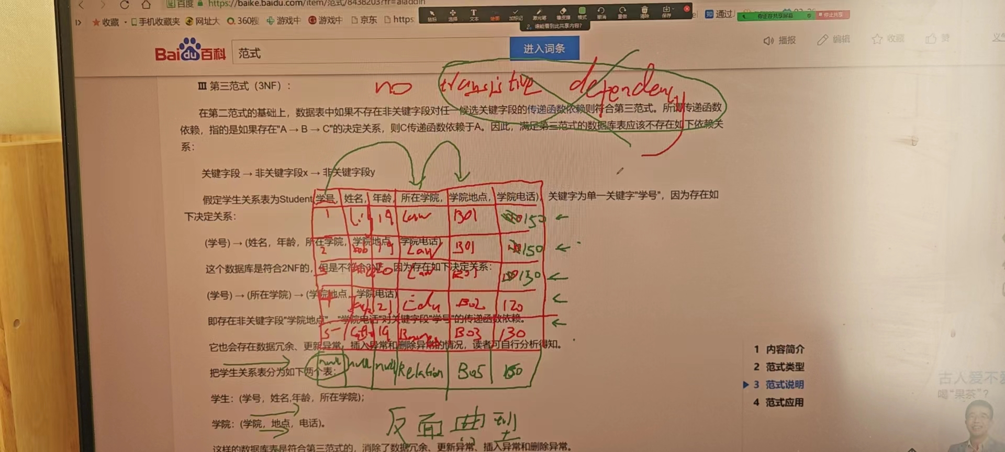

Candidate key(Secondary key): an attribute or a set of attributes which could be primary key

data dictionary:

metadata about database

e.g.

table name,

column name,

data type,

primary key/foreign key

logic schema:

an overview of database

use methods such as entity relationship diagram